Title
Assignment 1: Making Decisions Based on Demand and Forecasting
By
Ogbeide, Kingsley
ECO 550047VA016-1136-001 – Managerial Economics and Globalization
Strayer University
Submitted to
Prof. James Ibe, Ph.D.
July 21, 2013.
Assignment 1: Making Decisions Based on Demand and Forecasting
1. Using Excel or other calculation software, input the data you collected in criterion one to calculate an estimated regression. Then, from the calculation provided, interpret the coefficient of determination, indicating how it will influence your decision to open the pizza business. Explain any additional variables that may improve the coefficient of determination.
When we analyze the independent variable as pizza price and pizza sale (dependent variable), so we are getting:
Table 1.1
Price per pizza ($) P | sales per day (quantity) Y | promotional expenditures per day ($) A | disposable income (M) ($) M |
5.99 | 90 | 130 | 37.5 |
6.99 | 80 | 120 | 38.5 |
7.99 | 70 | 110 | 39.5 |
8.99 | 60 | 100 | 40.5 |
9.99 | 50 | 90 | 41.5 |
A linear demand model would be specified as follows:
Q=a+B1A+B2P+B3M+e
But for our case we will take a simple linear regression model, so we will limited the section to the simplest case of one independent and one dependent variable, where the form of the relationship between the two variables is linear:
Y=a+bX
So instead of X we put the data from the table: P, M, A.
Although there are several methods for determining the values of a and b (that is, finding the regression equation that provides the best fit to the series of observations), the best known and most widely used is the method of least squares. b is a slope and a is an intercept. Putting all the data in Microsoft Excel we are getting the slope = -10 and intercept = 149.9 (for the pizza sale P and the price of pizza Y dates only). Table 1.2

Table 1.2
Price per pizza ($) P | sales per day (quantity) Y |
5.99 | 90 |
6.99 | 80 |
7.99 | 70 |
8.99 | 60 |
9.99 | 50 |

Table 2.1 shows us that the less the price, the more demand for the pizza. So we can also say that the price is elastic in the pizza case.
Table 2.1. That is what we are getting for the regression equation line:

Table 3.1. That is what we are getting after the calculation:
Price per pizza ($) | sales per day (quantity) |
5.99 | 90 |
6.99 | 80 |
7.99 | 70 |
8.99 | 60 |
9.99 | 50 |
Slope:-10 | Intercept: 149.9 |
Mean 7.99 | Mean: 70 |
Standard deviation: 1.414213562 | Standard deviation: 14.14213562 |
Now we can also figure out the correlation coefficient R and the coefficient of determination R squared also using the Microsoft Excel (also from the formulas provided in Microsoft Excel).
R will be equal -1
R squared -1
So the negative coefficient shows that as the independent variable (Xn) changes, the quantity demanded changes in the opposite direction. So the decision on opening a pizza place will be depended on total cost of the pizza, the less the price, the more quantity demanded (McGuigan, 2011).
Well, in other example we can take the A (the promotional expenditures, $), also after calculating all the data’s, we are getting the following:
Table 3.2
Promotional expenditures ($) | sales per day (quantity) |
130 | 90 |
120 | 80 |
110 | 70 |
100 | 60 |
90 | 50 |
Slope: 1 | |
Intercept:-40 | |
Mean: 110 | Mean: 70 |
Standard deviation: 14.14213562 | Standard deviation: 14.14213562 |
R squared: 1 | R: 1 |
Regression equation line:
Positive coefficient shows that as the independent variable (Xn) changes, the quantity demanded changes in the same direction. So the more money we spend on the promotion, the more we are getting pizza sales.

Table 3.1
Market | Demand (Q) | Price (P) | Competitor Price (P_{x)} | Advertising (Ad) | Income (I)
1 | 596,611 | 7.62 | 6.54 | 200,259 | 54,880
2 | 596,453 | 7.29 | 5.01 | 204,559 | 51,755
3 | 599,201 | 6.66 | 5.96 | 206,647 | 52,955
4 | 572,258 | 8.01 | 5.30 | 207,025 | 54,391
5 | 558,142 | 7.53 | 6.16 | 207,422 | 48,491
6 | 627,973 | 6.51 | 7.56 | 216,224 | 51,219
7 | 593,024 | 6.20 | 7.15 | 217,954 | 48,685
8 | 565,004 | 7.28 | 6.97 | 220,139 | 47,219
9 | 596,254 | 5.95 | 5.52 | 220,215 | 49,775
10 | 652,880 | 6.42 | 6.27 | 220,728 | 54,932
11 | 596,784 | 5.94 | 5.66 | 226,603 | 48,092
12 | 657,468 | 6.47 | 7.68 | 228,620 | 54,929
13 | 519,866 | 6.99 | 5.10 | 230,241 | 46,057
14 | 612,941 | 7.72 | 5.38 | 232,777 | 55,239
15 | 621,707 | 6.46 | 6.20 | 237,300 | 53,976
16 | 597,215 | 7.31 | 7.43 | 238,765 | 49,576
17 | 617,427 | 7.36 | 5.28 | 241,957 | 55,454
18 | 572,320 | 6.19 | 6.12 | 251,317 | 48,480
19 | 602,400 | 7.95 | 6.38 | 254,393 | 53,249
20 | 575,004 | 6.34 | 5.67 | 255,699 | 49,696
21 | 667,581 | 5.54 | 7.08 | 262,270 | 52,600
22 | 569,880 | 7.89 | 5.10 | 275,588 | 50,472
23 | 644,684 | 6.76 | 7.22 | 277,667 | 53,409
24 | 605,468 | 6.39 | 5.21 | 277,816 | 52,660
25 | 599,213 | 6.42 | 6.00 | 279,031 | 50,464
26 | 610,735 | 6.82 | 6.97 | 279,934 | 49,525
27 | 603,830 | 7.10 | 5.30 | 287,921 | 49,489
28 | 617,803 | 7.77 | 6.96 | 289,358 | 49,375
29 | 529,009 | 8.07 | 5.76 | 294,787 | 48,254
30 | 573,211 | 6.91 | 5.96 | 296,246 | 46,017
 | 17,952,346 | 207.87 | 184.90 | 7,339,462 | 1,531,315

Table 23.2
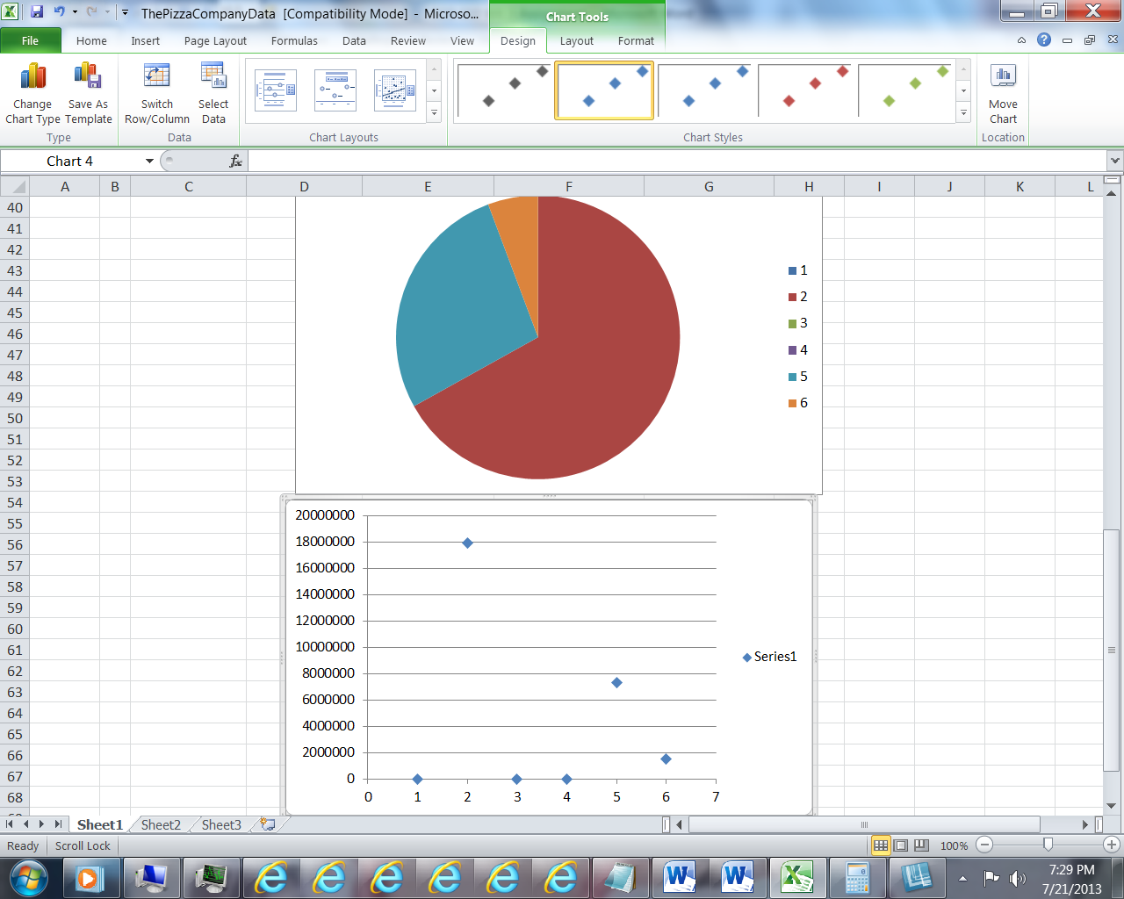

Table 3.3

2. Test the statistical significance of the variables and the regression equation, indicating how it will impact your decision to open the pizza business.
The need to do the regression equation for every independent variable to figure out our coefficient of determination. In every case it will be different, since the coefficient will be changed for each data we use from independent variables. But if the coefficient is negative, that will show us that the independent variable and quantity demanded changes in the different direction and opposite (if the coefficient of determination is positive, the both data’s will change in the same direction).
The cost of pizza itself will influence the price for pizza, so the customers have an option to pick their own ingredients, that cost less (for example tomatoes < red bell peppers) and the price will be also variable from the topping option (Shacklett, 2010). Pizza can be healthy! Domino's nutritional calculator, referred to as the Cal-O-Meter, gives customers the opportunity to build their own pizza and count the calories as items are added and deleted from their order," said Jenny Fourscore, Domino's Pizza spokesperson "The website also lists several lighter options for customers to order if they don't wish to build their own pizza (Domino's Pizza, 2009).
0.71 quantities. | Coefficients | Standard Error | t Stat | P-value | Lower 95% | Upper 95% |
Intercept | 149.9 | 0 | 65535 | #NUM! | 149.9 | 149.9 |
5.99 | -10 | 0 | 65535 | #NUM! | -10 | -10 |
The standard error of estimate (Se) can be used to construct prediction intervals for Y. an approximate 95 percent prediction interval is equal to Y±2Se Suppose we want to construct an approximate 95 percent prediction interval for the pizza sale with the pizza price 6.99. Substituting Y=80, Se=-0.71
Our prediction interval will be from 78.58 to 81.42 quantities with the pizza sales of $6.99

3. Test the statistical significance of the variables and the regression equation, indicating how it will impact your decision to open the pizza business.
It can be found that the regression model is dependable, however; it is only as good as the variables that are used in the model. We must test the variables; population, income and price, to ensure as a whole there is relationship between the dependent variable, pizza sold. This helps to determine if the prediction of the model is a pattern rather than just a chance. We will compare Significance F (.000761528) from our model to a level of significance of .05 (i.e., 5 percent). This means that we have less than 5% chance of the model being wrong. Based on .000761528 being smaller than .05, I conclude that at the 5% level of significance a positive relationship exists between population, income, and price to pizza sold. I would continue to contemplate starting a pizza business in the city.

4. Forecast the demand for pizza in your community for the next four (4) months using the regression equation, including the assumptions that were used to create the demand. Justify the assumptions made related to the forecast.
Using the demand function I came up with the following four (4) year forecast for pizzas sold.
|Year |Sold |Population |Median Household Income |Price
|2014 |$737,043.10 |65,756 |$29,822.00 |$10.09
|2015 |$799,299.67 |66,710 |$30,362.00 |$10.12
|2016 |$817,875.11 |67,215 |$31,541.00 |$10.15
|2017 |$937,043.10 |68,756 |$32,912.00 |$10.30

Now based the population growth assumption by taking the 2011 estimation from the Census Bureau, which was 2.4% increase from 2010, and applied to each year (Census Bureau, 2012). For the median household income, I applied .78% increase for each year based on the average growth from 2006 to 2010. For 2011, the price of pizza the same and increase by .31% thereafter. The price of pizza over the years has not grown in comparison to population and income, however; I felt that the price should increase given basic inflation. . Forecast the demand for pizza in your community for the next four months using the regression equation, including the assumptions that were used to create the demand. Justify the assumptions made related to the forecast.
A regression equation can be used to make predictions concerning the value of Y, given any particular value of X. This is done by substituting the particular value of X, namely, Xp, into the sample regression equation Y=a+bX, where as you recall, Y is the hypothesized expected value for the dependent variable from the probability distribution p(Y/X). Suppose one is interested in predicting Pizza sales with the price of pizza 6.99, so substituting Xp =6.99 into the estimated regression equation yields (take the data from table 3.1:
Y=149.9+ (-10)*6.99=80 (quantity of pizza).
Based on the forecasting demand, determine whether Dominos should establish a restaurant in your community. Provide a rational and support for the decision (Areavibes, 2012).
The forecast demand was taken from a regression model that was reliable with an 89.2% adjusted coefficient of determination, meaning that 89.2% of changes in the dependent variable account for the changes in the independent variables. The independent variables are significant based on a .000761528 Significance F in the regression, we have, less than a 5% chance of this model given us false information. The forecast for the first year shows sales of $737,043 and $937,043.10 for year four. This will result to a steady sales increase of 2.7%. Given the model has proved to be fit for our purpose, the data in the model has been confirmed to be adequate, the assumptions are in line with historical data, and along with the amount of forecasted sales; I believe it can be justified to establish a new Dominoes in the area.

References
Areavibes. (2012). Retrieved from: http://www.areavibes.com/homestead-fl/cost-of-living/
Census Bureau. (2012). 2010 Census. Retrieved from: http://www.census.gov/
City of Homestead. (2012, September). Retrieved from: http://www.cityofhomestead.com/index.aspx?NID=187
McGuigan, J. R., Moyer, R. C., & Harris, F. H. D. (2011). Managerial economics: Applications, strategy, and tactics (12th ed.). Mason, OH: South-Western Cengage Learning.Newman, J., Wiederhold, T. (2012). Local Area Personal Income for 2010. Survey of Current Business, (5), 51,
PMQ Pizza Magazine. (2011, April). 2011 Pizza Report. Retrieved from: http://pmq.com/industryreports.php
Shacklett, M. (2010). You Made the Investment-Now What?. World Trade, WT 100, (12), 20
Domino's Pizza; As the Ball Drops, Sales Rise for Domino's Pizza. (2009). Science Letter, 2923,

